Nmap Lab Documentation

- Nmap Version checking:

nmap -v

This command checks the version of nmap installed in the kali machine

- Host Discovery:

nmap -sn 10.71.75.192/24

This command finds live hosts without scanning ports

- OS Fingerprinting:

sudo nmap -O 10.71.75.182

This command tries to identify the operating system of the target

- Aggressive Scan:

nmap -p53 -sV -A 10.71.75.182

This command does a few things. Here’s a simple breakdown of the command:
- -p53 Specifies the port number being targeted on the host which in my case was 53
- -sV tries to determine the software and versions running on this port
- -A this means aggressive scan which enables you to gather a lot of information like OS version, Version Detection and much more in a single command without specify which option you want to use.

- Basic NSE Script scan:

nmap --script=default 10.71.75.182

This command runs safe NSE Scripts to gather extra information.

Additional commands

- ip route- This command is used to show or modify your device’s routing table, which a computer uses to determine the best path to send network traffic to a specific destination.

- sudo tcpdump -i wlan0 -s 0 -w mark.pcap- This command records all wireless network traffic to a file for later analysis. The command tcpdump is a network packet sniffer which listens to all the conversations happening in your network and shows them to you. Here’s a simple breakdown of the rest of the commands:

- -i wlan0 - this means “Listen on the WI-FI Interface”
- -s 0 - this means “Capture the ENTIRE Packet”
- -w mark.pcap - this means “Write/Save to a file named mark.pcap”

- ls mark.pcap - this command checks whether the file mark.pcap saved in the current directory.

- wireshark - this command opens up the wireshark graphical user interface. Wireshark is used to capture and examine traffic moving across a network in a graphical user interface instead of using the terminal.
In Wireshark you need to choose the interface that you captured the traffic from which in my case was wlan0.

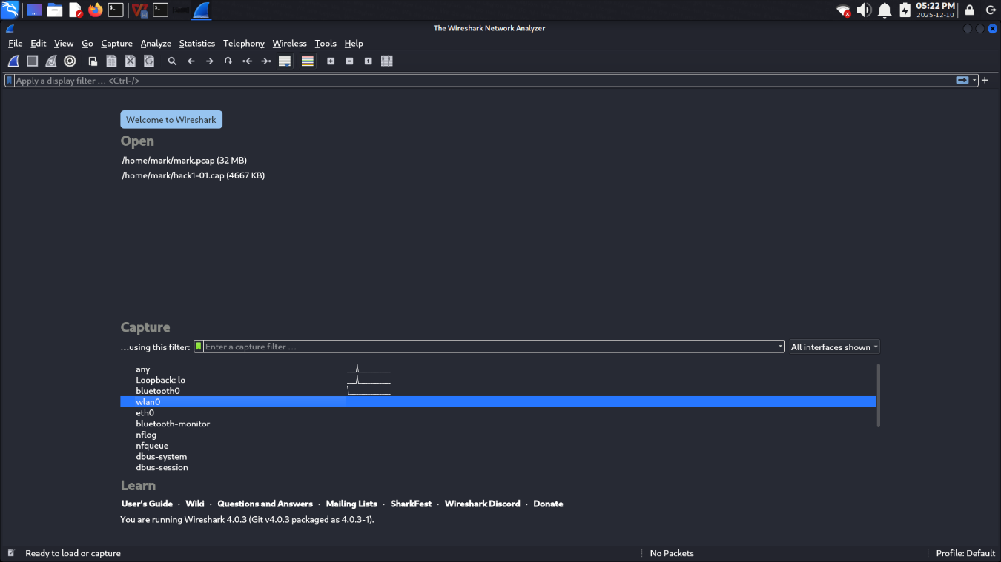
After that you need to navigate to the where you had saved your .pcap file was saved, which was /home/mark in my case and open it. The name of my file was mark.pcap

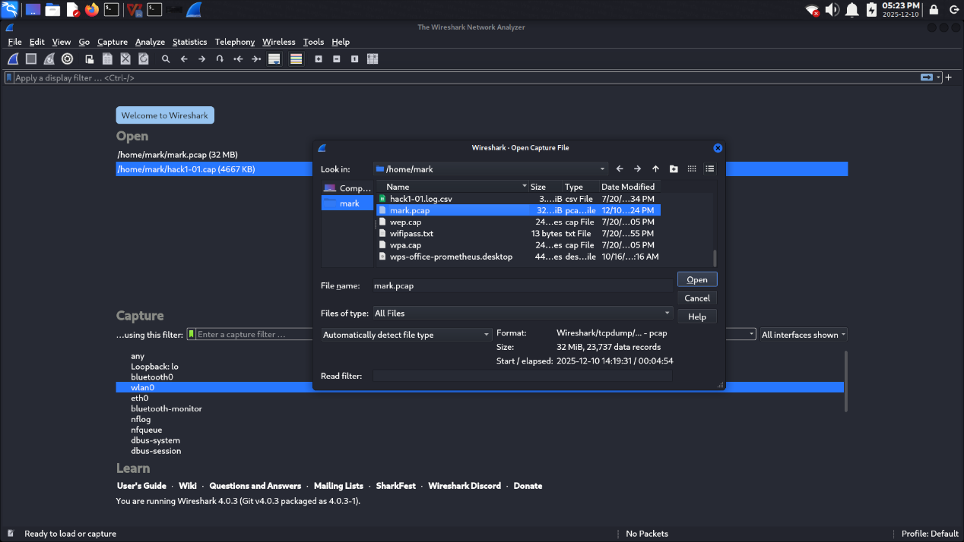

The mark.pcap file will be displayed and the following output will be shown:

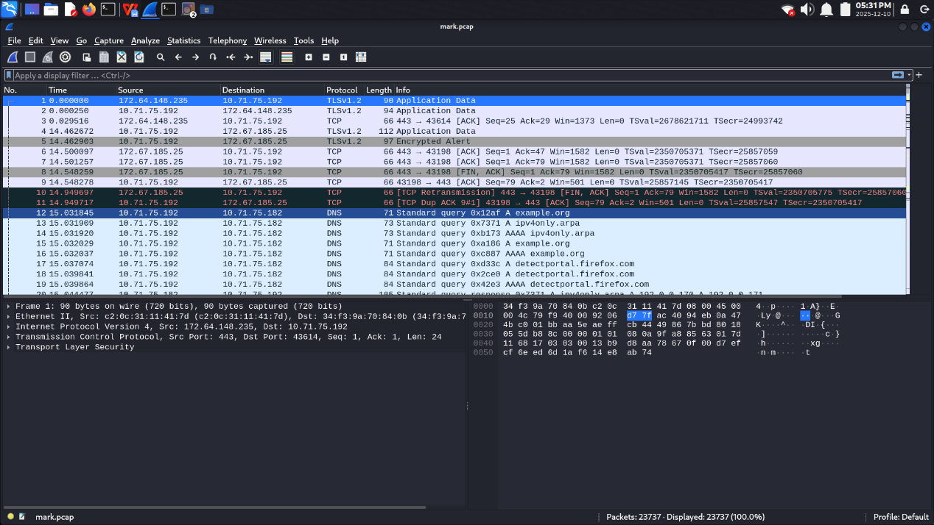

I learnt that you can filter specific traffic like DNS traffic and icmp traffic if you want to analyze specific traffic.

DNS Traffic Output:
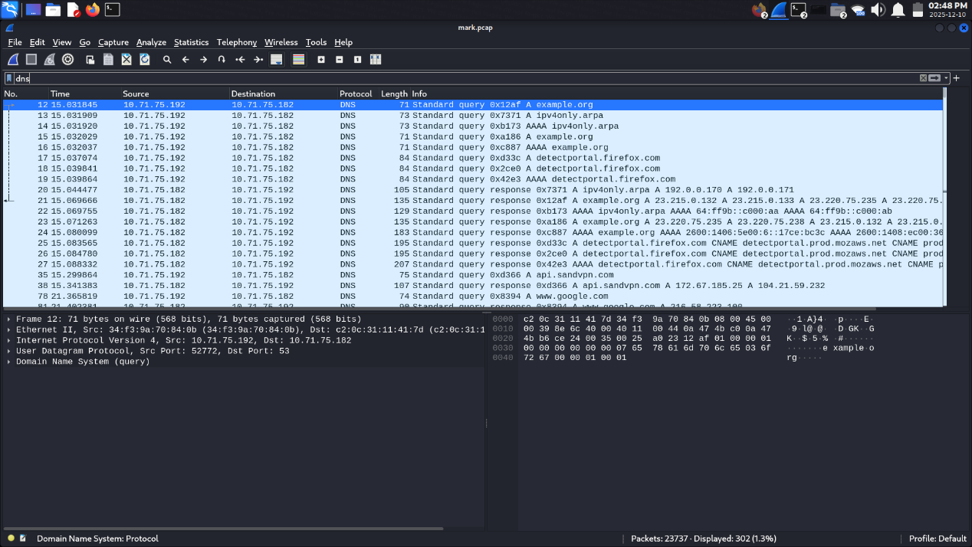

icmp Traffic Output:

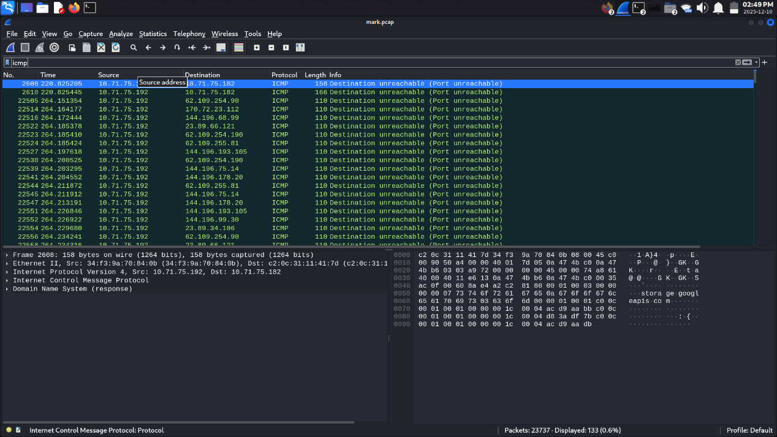

The other screenshots are stored in /nmap/screenshots/ path.
Each screenshot is labelled according to the scan type.

